**Week 6 of Distant Learning lessons May 11 – May 15**

**Monday May 11, 2020**

**Objectives: 1) I can know the difference between your and you’re.**

**2) I can read an article and know what a GIF is.**

**Directions: Read the story below and answer all the questions that follow.**

He Makes GIFs for a Living!

Danny Chang works with celebrities to bring you the perfect reaction for every situation.

[MARCH 2020](https://action.scholastic.com/issues/2019-20/030120.html)

By Anna Starecheski



Courtesy of GIPHY

    GIFs have changed how we communicate and share our feelings. Let’s say you can’t wait to hang out with your best friend after school. Sending him a moving picture of Thor screaming “Yesssssss!” says way more than a regular text message, right?

    GIPHY [GIF-ee] is a company that makes sending that funny message possible. Even if you don’t use its app, you’ve probably seen its GIFs on Instagram, Snapchat, and more.

    We talked to Danny Chang, the director of partnerships at GIPHY. It’s his job to work with celebrities to create the GIFs you love.



Neveshkin Nikolay/Shutterstock.com

**You’re the director of partnerships. What does that mean?**

    I work with music and sports companies to get GIFs onto GIPHY. So take Lil Nas X, for example. When he released the video for “Old Town Road,” we had GIFs ready for fans to use right away. I also work with celebrities who come in and do video shoots just for GIFs.

**How do you decide what makes the perfect GIF?**

    It has to be short and look good as it loops—or plays on repeat. It also has to show an emotion that everyone can relate to.

**What’s your favorite GIF you’ve worked on?**

    We had the rapper Lil Yachty come in for a video shoot. We made this GIF where he’s furiously hitting buttons on a video game controller. Then our artists drew a bunch of cartoon coins coming out of the controller. I love how it shows excitement!

**What has helped you succeed in your job?**

    I love people! Being a “people person” is super important in my position. Everyone I work with has to trust me. And it helps if they like me too!

**What’s the most difficult part of your job?**

    There never seems to be enough hours in the day to get everything done. I have to work hard to set goals and figure out which tasks are most important.

**Do you have any career advice for our readers?**

    Learn how to listen, take in information, and learn. Everyone you meet has something to teach you.

Mini Skills Workout

1. Lil Yachty “furiously” hit buttons on a game controller. What does *furiously* mean?
2. What are two things the perfect GIF needs?
3. Find a sentence in which Danny explains how gets everything done. Write it here.

Name: ______________________________ Date: ___________________

You’re or Your ?

Rules for using you’re and your Use YOU’RE in place of “you are.” Find a sentence that uses you’re in the article. Write it on the line below.

___________________________________________________________________________________ Use YOUR to mean “belonging to you.” Find a sentence that uses your in the article. Write it on the line below.

____________________________________________________________________

Directions: Each sentence below is missing the word you’re or your. Read the rules, and then fill in each blank with the correct word.

1. When __________ texting, GIFs are a fun way to show emotions.

2. You can show that __________ tired with a GIF of someone falling asleep.

3. You can express __________ anger with a GIF of a snarling tiger.

4. If __________ making a GIF to amuse a friend, take Danny Chang’s advice.

5. Think about the feeling __________ trying to show.

6. Will you use photos from __________ school dance?

7. Do you have a video of __________ brother celebrating a touchdown?

8. If __________ creative and focused, you can make an amazing GIF!

**Tuesday and Wednesday May 12 – May 13.**

**Objectives: I can read an article about what billionaires do with their money and answer detail questions to write a summary.**

**Directions: Read the article below and answer the questions that follow.**

The Billionaire Club By Tod Olson

About 600 billionaires live in the United States. How did these people become so rich? And what do they do with all that money? Read on to find out.

[MARCH 2020](https://action.scholastic.com/issues/2019-20/030120.html)

Meet Jeff Bezos, the richest person in the world. He started Amazon—the online store that sells almost everything. And now, Bezos can buy almost anything. He’s worth about $118 billion.

    Write it out and it looks like this: $118,000,000,000.

    How much money is that? Take the 60 million Americans with the least amount of money. Add it all up. Bezos is richer than all of them put together.

    Does that sound fair? Some people say no. They believe that billionaires should not be allowed to get that rich.

    Chances are you’ve never met a billionaire before. (They don’t usually hang out at your local supermarket.) So let’s take a look inside their lives.

https://action.scholastic.com/content/dam/classroom-magazines/action/pages/misc/lightbulb.png

PAUSE AND THINK: Who is Jeff Bezos? How much is he worth?

Making Money

    There are more than 2,000 billionaires in the world. About 600 of them live in the United States. Most of them got rich by starting companies. They run banks. They own factories that make cars and candy and computers.

    Some of the world’s newest fortunes come from [**technology**](javascript:void(0);). Bill Gates started the [**software**](javascript:void(0);) company Microsoft. He’s the second richest person on Earth, with about $114 billion. Mark Zuckerberg started Facebook. He’s in fifth place with about $80 billion.

    At 22, Kylie Jenner is the youngest billionaire. She became famous on reality TV. But like Zuckerberg, she owes her fortune to the internet. Most of her money comes from her makeup company, Kylie Cosmetics. It turned her 156 million Instagram followers into paying customers.

https://action.scholastic.com/content/dam/classroom-magazines/action/pages/misc/lightbulb.png

PAUSE AND THINK: How have most billionaires gotten rich?

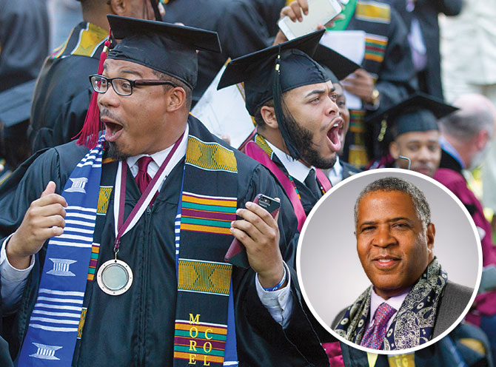

Simon Dawson/Bloomberg via Getty Images (Robert Smith); Steve Schaefer/Atlanta Journal-Constitution via AP Images (Graduates)

**Giving Back**   
Morehouse College graduates (above) celebrate after hearing that Robert Smith (left) would pay off their debt.

Living the Dream

    A billion dollars can buy a pretty nice life. Bezos has at least six homes. (His ranch in Texas is twice the size of Manhattan.) A Russian billionaire owns a 500-foot yacht with its own submarine. A British billionaire lived in a house in Los Angeles with parking for 100 cars. She just sold it—for $120 million.

    Some billionaires hire fancy companies to help them spend their money. These companies find tables at the finest restaurants. They plan expensive vacations and organize events. One company even provided 30 live penguins for a party in England.

    But at the same time, 37 million Americans struggle to put food on the table. Since billionaires have so much money, should they have to do more to help people in need?

https://action.scholastic.com/content/dam/classroom-magazines/action/pages/misc/lightbulb.png

PAUSE AND THINK: What are two ways that billionaires spend their money?

Share the [**Wealth**](javascript:void(0);)

    Some people say yes. They think that billionaires should have to pay more [**taxes**](javascript:void(0);). In their opinion, the money from those taxes could make the country a better place for all Americans. They say it could be used to do everything from building better roads to helping students pay for college.

    But other people think forcing billionaires to pay more taxes is unfair—and a bad idea. They say billionaires are already helping people. The businesses they build create millions of jobs.

    Plus, rich people don’t just spend their money on yachts and houses. Many of them share their wealth. For example, Bill Gates gave $5 billion to fight poverty in 2018. And billionaire Robert Smith paid off the college [**debts**](javascript:void(0);) of all the 2019 graduates of Morehouse College.

    Who knows, one of those graduates might someday join the billionaire club. If you were to become one of them, what would you do? Buy a private island? Send poor kids to college? Give some money to the government?

    With a billion in the bank, you could probably do all three.

https://action.scholastic.com/content/dam/classroom-magazines/action/pages/misc/lightbulb.png

PAUSE AND THINK: How do some billionaires use their money for good?

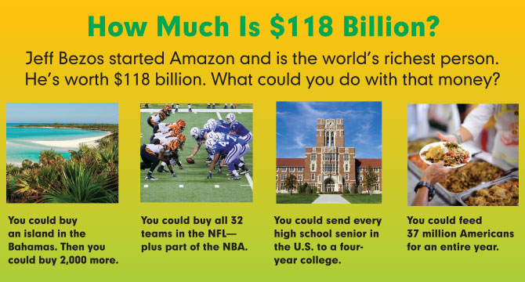

**Billionaire Questions**

1. **Who is Jeff Bezos? How much is he worth?**
2. How have billionaires gotten rich?

______________________________________________________________________________  
  
______________________________________________________________________________  
  
______________________________________________________________________________

1. What are two ways that billionaires spend their money?

______________________________________________________________________________  
  
______________________________________________________________________________  
  
______________________________________________________________________________

1. How do some billionaires use their money for good causes?

_____________________________________________________________________________

_____________________________________________________________________________

_____________________________________________________________________________

A summary is a short retelling of the most important parts of an article. It should include the information that someone would need to know to understand the article.

**Directions**: Complete the summary below based on your reading of “The Billionaire Club.” Think about what was most important in the article.

The article “The Billionaire Club” is about

.

The number of billionaires in the world is more than

Most billionaires made their money by

Billionaires sometimes hire companies to help them spend their money by

Some people think billionaires should pay more in

They say that the money can be used to

But other people say that idea is unfair for two reasons:

1)

2)

“The Billionaire Club” Quiz

Directions: Circle the best answers for questions 1-6.

1. The author compares Jeff Bezos to 60 million Americans to show ______.

A how rich Bezos is

B how old Bezos is

C how Bezos made his money

D why Amazon is popular

1. The section “Making Money” is mainly about ______.

A how many billionaires there are

B how billionaires earn their money

C why billionaires want to make money

D why some billionaires go on reality shows

1. According to the article, which industry is the source of many recent fortunes?

A candy

B shoes

C makeup

D technology

1. Which section mentions a party with penguins?

A the introduction (first section)

B “Making Money”

C “Living the Dream”

D “Share the Wealth”

1. A person would have debts if they ______.

A voted in every election

B got plenty of exercise

C read a newspaper

D borrowed money for a vacation

1. Why does the author include the detail about Bill Gates giving $5 billion to fight poverty?

A to explain how he started his company

B to show that some billionaires share their wealth

C to tell how becoming famous can help you get rich

D to explain why Jeff Bezos is the richest person in the world

1. The author says “Like Zuckerberg, Kylie Jenner owes her fortune to the internet.” What does the author mean?
2. Based on the article, do you think billionaires should pay more in taxes? Why or why not?

Thursday and Friday May 14-May14

Objectives: I can find text evidence, acquire new vocabulary, use inferencing skills, and find the central idea and details in a nonfiction text.

Directions: Read the article and answer the following questions.

Malala the Powerful

The true story of a teen girl who almost died for her right to go to school

[FEBRUARY 2020](https://action.scholastic.com/issues/2019-20/020120.html)

By Kristin Lewis

October 9, 2012, was an ordinary afternoon in the Swat Valley in northern Pakistan. Malala Yousafzai [yoo-suf-ZEYE], 15, was on a school bus waiting to go home. Suddenly, two gunmen in masks appeared.

    “Who is Malala?” one of them yelled.

    A feeling of terror filled the bus. Then the gunmen opened fire. One bullet hit Malala’s head. Two of Malala’s friends were struck in their arms. Then the gunmen ran off, leaving Malala to die.

It might be difficult to understand why anyone would try to murder an innocent girl on her way home from school. But some people in Pakistan did not view Malala for what she was: a bright and kind teenager. They saw her as a dangerous threat to their way of life.

    Malala had been fighting for the right for all girls to go to school—work that made her famous around the world.

    It also made her a target of an evil group of [**terrorists**](javascript:void(0);) called the Taliban.

Taliban Control

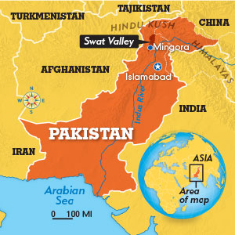

Jim McMahon/Mapman ®

**[The Swat Valley](https://action.scholastic.com/issues/2019-20/020120/malala-the-powerful.html)** [Malala is from Mingora, a city in the Swat Valley. The area is known for its green mountains, thick forests, and mighty rivers.](https://action.scholastic.com/issues/2019-20/020120/malala-the-powerful.html)

    The Taliban were not part of Pakistan’s government, but their forces were powerful. Their members followed an [**extreme**](javascript:void(0);) form of the religion Islam. Most Muslims—people who follow Islam—do not agree with the Taliban.

    Malala is from Mingora, a city in the Swat Valley. Starting in 2007, the Taliban began taking control of Swat. They blew up government buildings and murdered police officers. At night, Malala often woke up to the sound of gunfire. Mingora became a war zone.

    Under Taliban control, people were forced to follow [**oppressive**](javascript:void(0);) religious rules. All music, television, and movies were banned. Women were not allowed to go to school or do any work outside of the home.

    If a person broke these rules, he or she could be beaten—or even killed.

Top Secret School

    In January 2009, the Taliban ordered all girls’ schools to close. That included Malala’s school, which her father owned.

    It was very upsetting news. School was one of the most important parts of Malala’s life, and she knew how lucky she was. After all, fewer than half the girls who lived in Pakistan’s countryside had a chance to go to school.

    Malala’s father made the dangerous decision to keep his school open. So Malala and her classmates stopped wearing their school uniforms. They hid their books under their clothing. Staying alive meant that going to school had to be top secret.

    Malala was scared—and angry. Was there anything she could do to fight back?

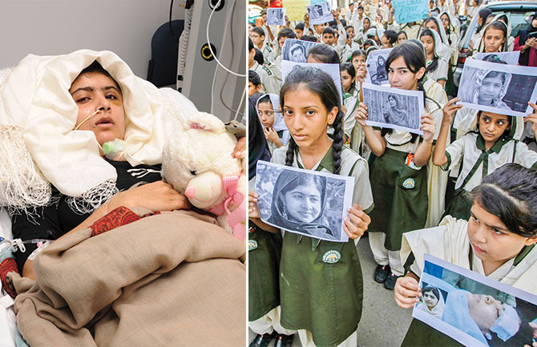**Fighting to Survive**  
Malala got better in a hospital in England. The bullet badly damaged her hearing and fractured—or cracked—her skull. (left)

**A Hero for Girls**  
Students in Pakistan hold up pictures of Malala. After the attack, people around the world gathered to show support for Malala and girls’ education. (right)

A Powerful Weapon

    It turns out that Malala had a powerful weapon of her own: her voice. And she would risk everything to use it.

    In 2009, she began writing for a British blog. Using a [**pseudonym**](javascript:void(0);), she shared what her life was like under the Taliban. She wrote about her dream of becoming a doctor one day and her fears of the terrorists. “On my way from school to home I heard a man saying, ‘I will kill you,’” she wrote.

    The blog was an instant hit. Soon, people all over the world were reading it—and learning what was happening in Swat.

Malala’s [**Crusade**](javascript:void(0);)

    In May 2009, the Pakistani army finally launched an attack against the Taliban in Swat. Along with millions of others, Malala and her family escaped to the south. The conflict lasted for three months. By August, it was finally safe to go home.

    After that, Malala began an attack of her own. She came forward as the famous blogger. She went on television and gave powerful speeches to Pakistani kids. Her message: All children deserve the right to an education.

    But in 2010, notes began appearing under Malala’s door. They ordered her to give up her crusade—or else. Still, she refused to back down. In October 2012, the Taliban shot her.

    After the shooting, Malala was flown to a hospital in England that treats serious brain injuries. Her family soon joined her. Meanwhile, the Taliban spoke out. They said the shooting was a warning to other girls not to follow Malala’s example.

    But people around the world weren’t scared. They continued Malala’s fight. Protesters marched—many of them were kids carrying signs that read “I Am Malala.”

What Girls Can Do

    It’s been a little more than seven years since the shooting. Malala survived, and her family stayed in England. There, Malala got the one thing she always wanted: an education.

    About 130 million girls around the world do not attend school. Often it is because they must work to earn money for their families. Sometimes it is because they have no school to go to. In 2014, Malala started the Malala Fund, a group that is working to change that.

    Today, Malala is a student at Oxford University in England. She isn’t sure what career path she will choose. But she knows she will keep fighting for girls and women: “If one girl with an education can change the world, just imagine what 130 million can do.”

Follow up Questions

Directions: Use text evidence or details to answer the following questions from the article.

1. What was life like under Taliban control?
2. What did Malala write about on her blog?
3. What “attack” did Malala begin in 2009?
4. Why did Malala start the Malala fund?
5. How has Malala used her voice to make life easier for herself and other girls?
6. Malala is often described as brave. How does this description fit her?